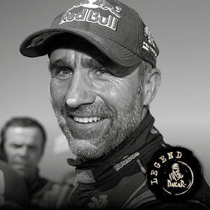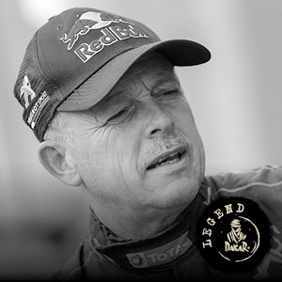
Stephane Peterhansel Jean Paul Cottret 300 PEUGEOT
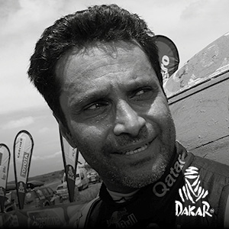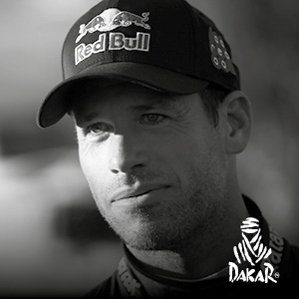
Nasser Al-Attiyah Matthieu Baumel 301 TOYOTA
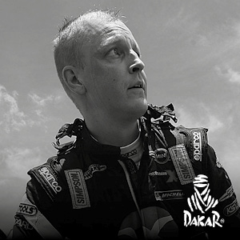
Mikko Hirvonen Michel Perin 303 MINI

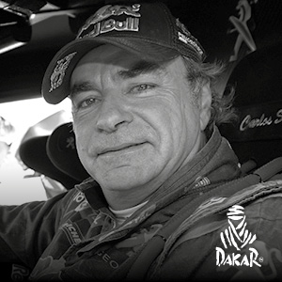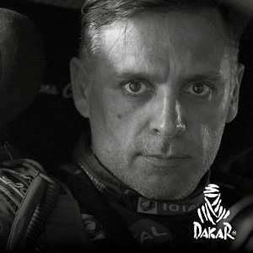
Carlos Sainz Lucas Cruz 304 PEUGEOT
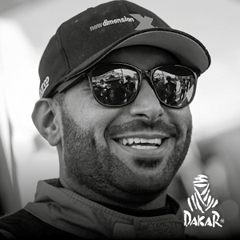
Yazeed Al Rajhi Timo Gottschalk 306 MINI
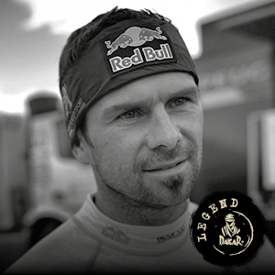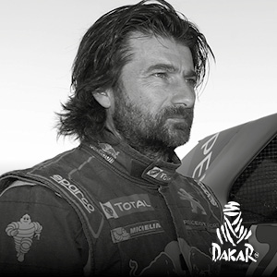
Cyril Despres David Castera 307 PEUGEOT

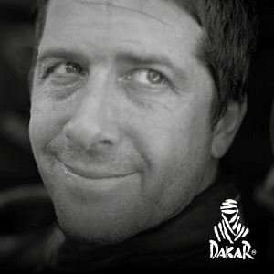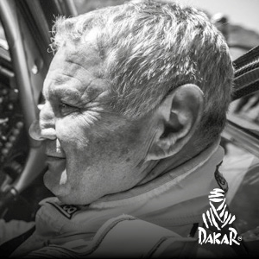
Orlando Terranova Andreas Schulz 308 MINI
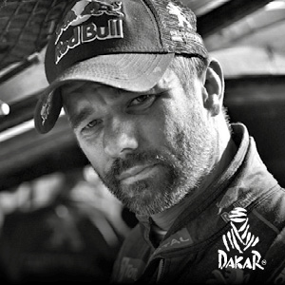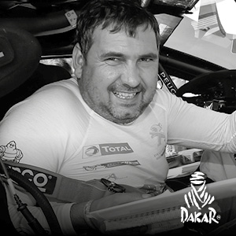
Sebastien Loeb Daniel Elena 309 PEUGEOT
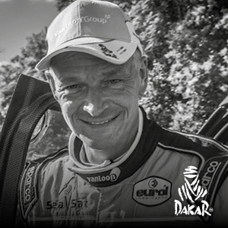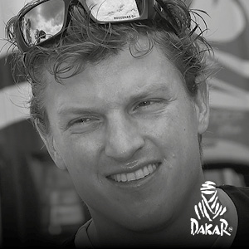
Loon Erik Van Rossegaar Wouter 301Toyota Hilux overdrive
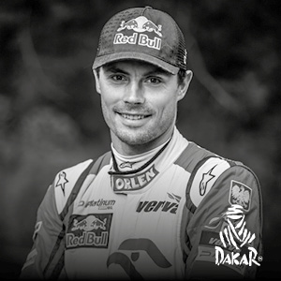
Jakub Przygonski Tom Colsoul 316 MINI

Ronan Chabot Gilles Pillot 317 TOYOTA
Romain Dumas Alain Guehennec 318 PEUGEOT

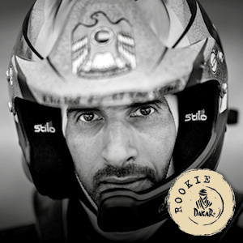
Sheikh Khalid Al Qassimi Pascal Maimon 319 PEUGEOT
Conrad Rautenbach Robert Howie 320 TOYOTA

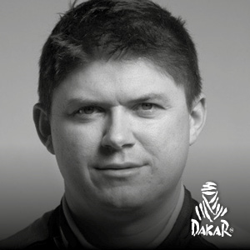
Martin ProkopI lka Minor 321 FORD
Mohammed Abu-Issa Xavier Panseri 322 MINI
Nicolas Fuchs Fernando Mussano 323 HRX
Marco Bulacia Claudio Bustos 324 FORD
Stephan Schott Paulo Fiuza 325 MINI

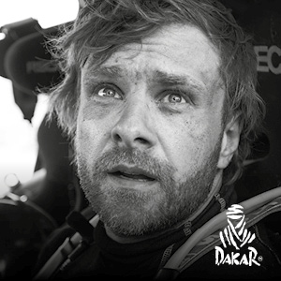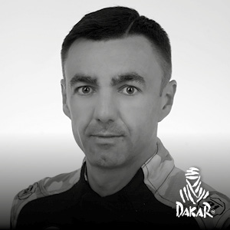
Benediktas Vanagas Rozwadowski Sebastian 326 TOYOTA

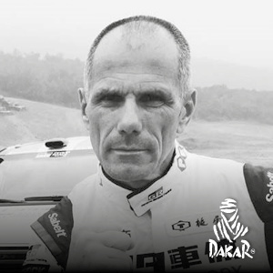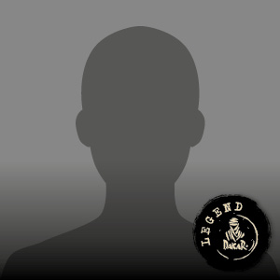
Christian Lavieille Jean-Pierre Garcin 327 TOYOTA

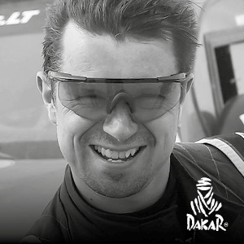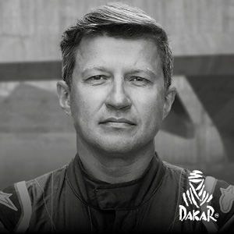
Antanas Juknevicius Darius Vaiciulis 328 TOYOTA
Juan SilvaSergio Lafuente 329 MERCEDES
Alejandro Miguel Yacopini Daniel Merlo 330 TOYOTA

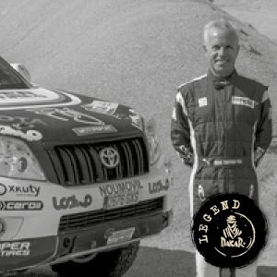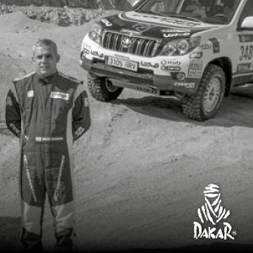
Xavier Foj Ignacio Santamaria 331 TOYOTA
Akira Miura Laurent Lichtleuchter 332 TOYOTA
Denis Berezovskiy Alexey Nikizhev 333 TOYOTA
Eric Bernard Alexandre Vigneau 335 BUGGY
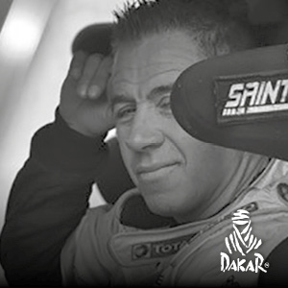
Jean - Pascal Besson Bruno Seillet 336 TOYOTA
Ronald Basso Julien Menard 337 NISSAN
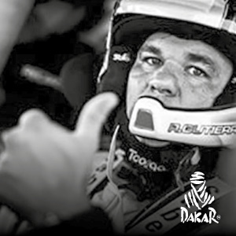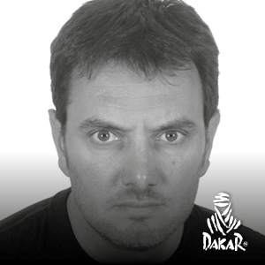
Alberto Rodrigo Gutierrez Fleig Joan Rubi 338 TOYOTA
Sylvio Barros 339 MINI

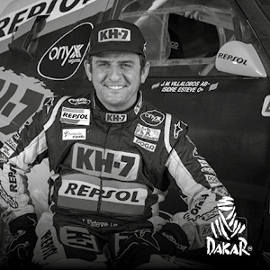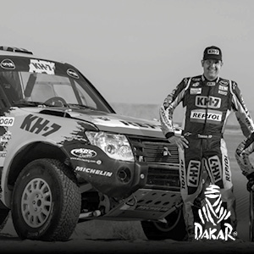
Isidre Esteve Txema Villalobos 340 MITSUBISHI
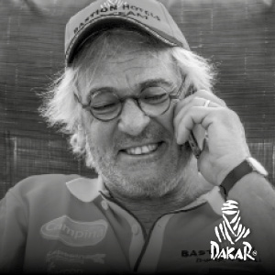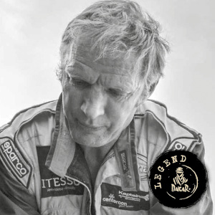
Maik Willems Robert Van Pelt 341 TOYOTA
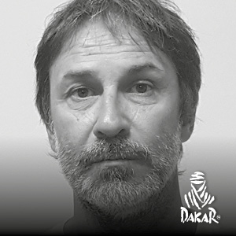
Eduardo Osvaldo Amor Nicolas Amor 343 TOYOTA
Martin Maldonado Sebastian Scholz Vergnolle 344 MERCEDES
Jose Antonio Blangino Luciano A. Gagliard i345 RAPIDO

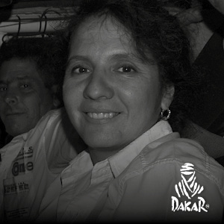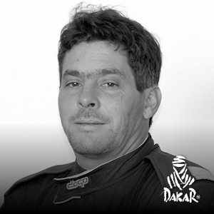
Alicia Reina Carlos Dante Pelayo 346 TOYOTA

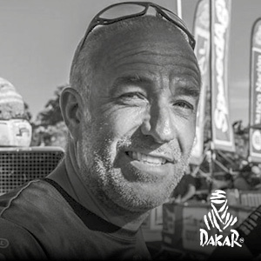
Tim Coronel 347 SUZUKI
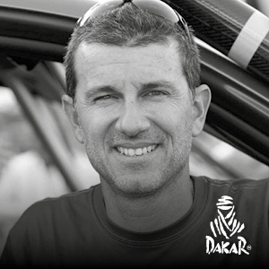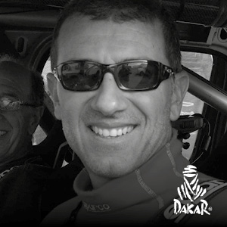
Fernando Ferrand Malatesta Fernando Ferrand Del Busto 348 TOYOTA

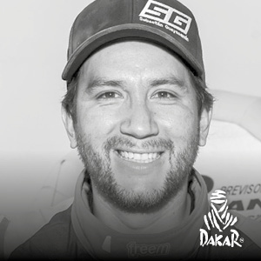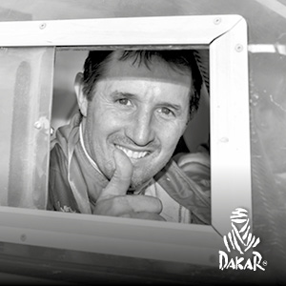
Sebastian Guayasamin Mauro Lipez 349 TOYOTA
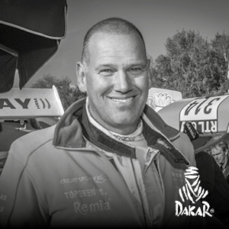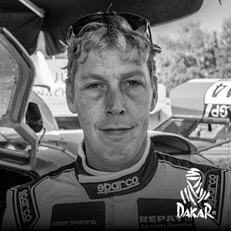
Ebert Dollevoet Patrick Van Lee 350 VOLVO
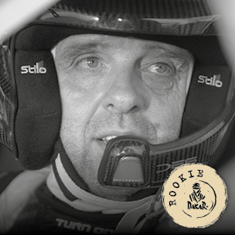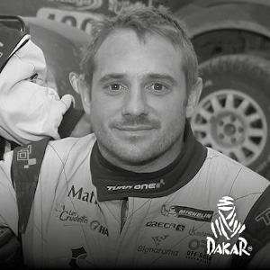
Philippe Croizon Cedric Duple 352 BMW

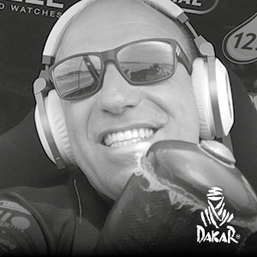
Tom Coronel 354 SUZUKI
Thomas Walter Englert Hans Paul Thiede Weiler 355 TOYOTA
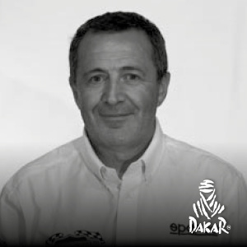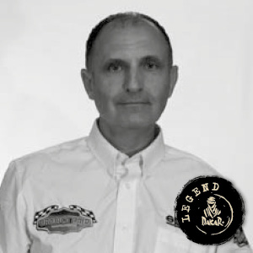
Giulio Verzeletti Antonio Cabini 356 FIAT
Yves Tartarin Stephane Duple 357 LAND-ROVER
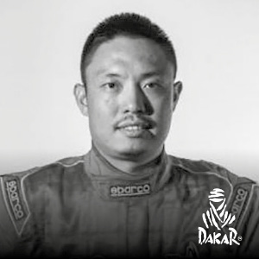
He Zhitao Kai Zhao 358 TOYOTA

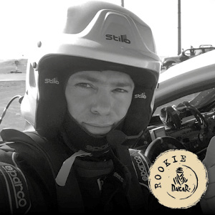
Gerard Tramoni Dominique Totain 359 SPRINGBOK MD
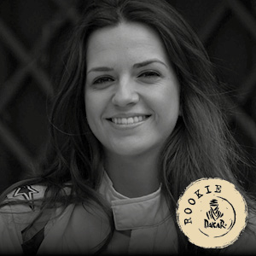
Cristina Gutierrez Herrero Pedro Lopez Chaves 360 MITSUBISHI
Luis Fernando Barbery Paz Salazar Abel Remberta Roca Zeballos 361 ToyotaAbel zar Abel
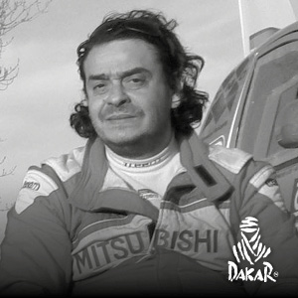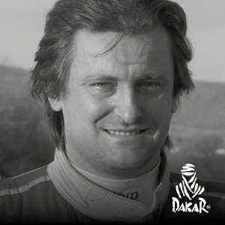
Gianni Luca Tassi Massimiliano Catarsi Alessandro Brufola Casotto 362 FORD
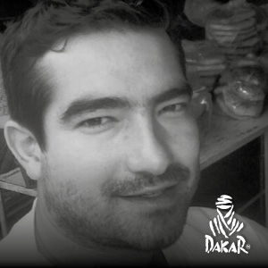
Julio Cesar Roca Mercado Hernan Daza Jimenez 363 TOYOTA
Juan Carlos Vallejo Leonardo Baronio 364 TOYOTA
Blas Zapag Enrique Zapag 367 TOYOTA
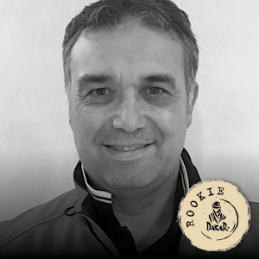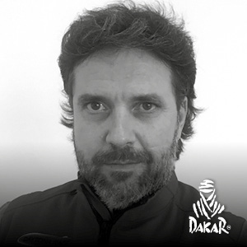
Graziano Scandola Giammarco Fossa' 368 FORD
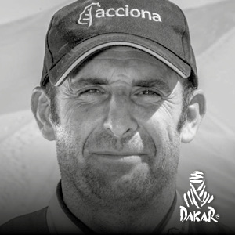
Ariel Jaton German Rolon 369 ACCIONA ECO POWERED
Gaston Jose Pasten Infante Fernando Acosta 371 TOYOTA
Vaidotas Zala Saulius Jurgelenas 373 SEAT

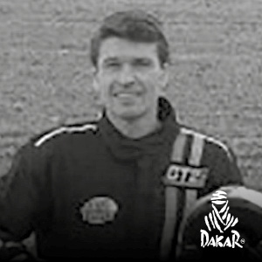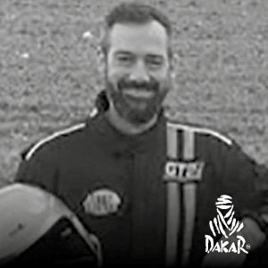
Tristan CouËDe lEdouard Sineux 375 LAND-ROVER
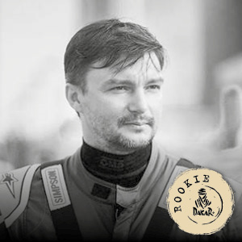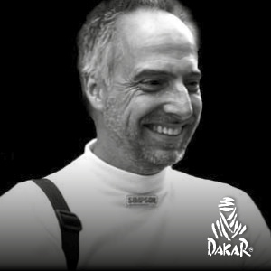
Roman Starikovich Bert Heskes 376 DESERT WARR
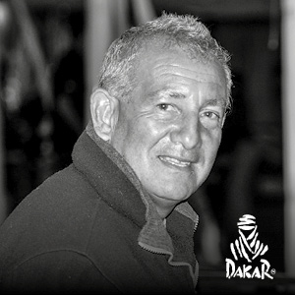
Carlos Alberto Villegas Aguero Maria Del Huerto Mattar Smith 377 NISSAN

Roberto Naivirt Jose Luis Di Palma 379 TOYOTA
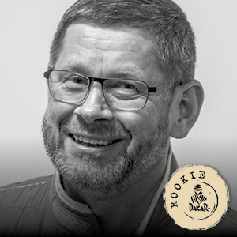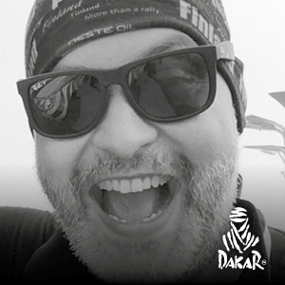
Sergei Shikhotarov Oleg Uperenko 380 TOYOTA
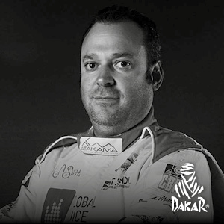
Stefano Marrini Stefano Rossi 381 TOYOTA
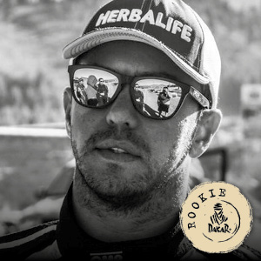 Eduardo Peredo Eugenio Arrieta 383 TOYOTA
Fortunato Maldonado Victor Alanoca 385 PUCH
Ramon Nunez Sergio David Casas 387 TOYOTA
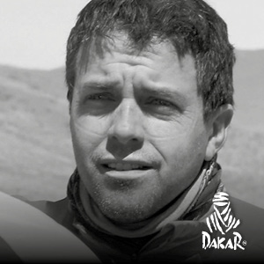
Orlando Careaga Enzo Cordano 389 TOYOTA
Marco Piana Steven Griener 390 TOYOTA

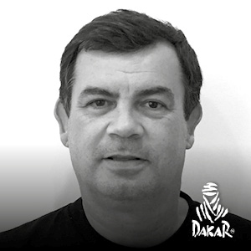
Roberto Recalde Juan Jose Sanchez 391 TOYOTA
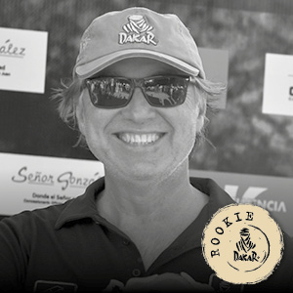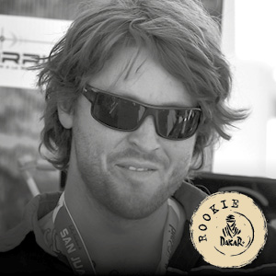
Carlos Hector Salom Lucas Javier Salom 393 VOLKSWAGEN

